**HOSPITAL PORTAL WEBSITE**

**Group Members:**

**1.Hatim Sawai - 2021300108**

**2.Kaif Sayyad - 2021300109**

**3.Dhruv Shah – 2021300113**

**Aim:** We aim to create a robust website to better connect the patients and their respective doctors of the hospital and also create a prototype for an online payment system.

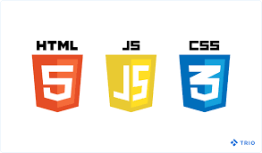

**Tech Stack:**

**Frontend:** HTML,CSS,JS

**Backend:** Python – Flask

**Database:** MongoDB

**Outline of Website:**

* **Homepage** of the website
* Consists of tabs: **Patients,Doctors,Services,About,Contact Us & Login**
* **Patients Tab:** Search Bar with patient’s records ordered from most recent to oldest up to a year
* **Doctors Tab**: doctors’ records who currently work there
* **Services Tab: Subtabs:** Pharmacy, Ambulance
* **Login Button:** Staff Login, Patient Login
* Login with Unique id: Staff_id/Patient_id & password
* **Staff Login:** Display Schedule for the day
* **Patient Login: Subtabs:** Appointments, Records, Payment Portal

**Timeline:**

**27/11/2022**

**15/11/2022**

**15/10/2022**

**1/10/2022**

**Complete Frontend aspect of the website**

**Complete Backend aspect of the website**

**Link frontend with database & final testing/debugging**

**Basic structure of project & gather resources**